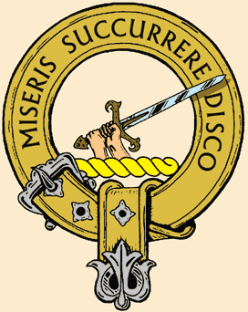
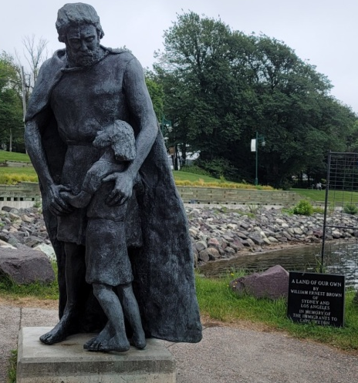
Tìr againn fhèin
(“A Land of Our Own”)
(Immigrants’ Memorial, Sydney Harbour, NS)
25th Gathering of the
Clan MacMillan
Society of North America
August 13-17, 2026
Sydney, Cape Breton, Canada
Rev. Dr. Chris McMullen, B.A., M.Div., D.Min., C.T.S., President and Host
Payment may be by cheque, international money-order or e-transfer.
$ 100 per person due on Registration; the balance by July 14, 2026,
or bring to the Gathering by special arrangement with Chris.
Mail or email to: Rev. Dr. Chris McMullen
2983 Route 121, Apohaqui, NB, Canada E5P 3W7
iandan@bellaliant.net (506) 608-8912
Registration Form
Name(s): ___________________________________________________________________
Full Address: ___________________________________________________________________
___________________________________________________________________
_______________________________________Postal Code: __________________
Email: __________________________________________________________________
Phone Number: ________________________________________________________________
Will you be staying at the Simon Hotel? (Yes/No): _____________________________________
Or alternate accommodation? Please identify: __________________________________________
Fees:
Fee for the whole Gathering (per person*): $ 620 Cdn. _____________________
Or: $ 475 US$ _____________________
Or: Partial Fees for certain days (See other page for detailed breakdown): _____________________
*Membership in Clan MacMillan Society of North America ($ 30/2 years): ____________________
Total: Paying Now: _______________ Before July 14: _______________

